A Major Project Abstract
On
Monkeypox Disease Detection using Deep Learning
Submitted to CMR ENGINEERING COLLEGE
BACHELOR OF TECHNOLOGY
IN
COMPUTER SCIENCE AND ENGINEERING
Submitted By
MURALA MAHESH CHANDRA | (228R5A0515)
PATLURY SRI VARSHA | (218R1A05H8)
KOMANGULA JAGADEESH | (218R1A05G5)
PONNALA LAVAKUMAR | (218R1A05I2)

Under the guidance of
Dr.G.Sumalatha

Associate Professor, Department of CSE

Department of Computer Science & Engineering
CMR ENGINEERING COLLEGE
UGC AUTONOMOUS
(Accredited by NBA Approved by AICTE,NEW DELHI, Affiliated to JNTU Hyderabad) Kandlakoya, Medchal Road, Medchal Malkajgiri Dist. Hyderabad-501 401)
2024-2025
ABSTRACT

Monkeypox is an infectious disease caused by the monkeypox virus (MPXV) that primarily affects animals but can be transmitted to humans, resulting in serious health implications. Early detection and accurate diagnosis of the disease are crucial for effective containment and treatment. Controlling the rapid transmission of the disease necessitates timely and accurate diagnosis, but the availability of traditional confirmatory tests, such as Polymerase Chain Reaction (PCR), remains limited. In this challenging scenario, by leveraging advanced technology, this approach can present a valuable alternative to conventional testing methods.

EXISTING SYSTEM

The existing system for monkeypox disease detection relied primarily on traditional diagnostic methods, including clinical examination and laboratory tests. When patients exhibited symptoms characteristic of monkeypox, healthcare professionals conducted a thorough physical examination to identify the presence of skin lesions or other associated signs.

To confirm the diagnosis, medical practitioners relied on laboratory tests, with the Polymerase Chain Reaction (PCR) being the gold standard. PCR allows the detection of specific monkeypox virus genetic material in patient samples, providing a definitive diagnosis. However, the availability and accessibility of PCR testing facilities were limited, especially in regions with resource constraints or during large-scale outbreaks.
- Furthermore, the process of obtaining and processing patient samples for PCR testing could be time-consuming, resulting in delays in confirming cases and implementing appropriate control measures. In addition to PCR, enzyme-linked immunosorbent assays (ELISA) and virus isolation methods were also employed, but they suffered from similar limitations in terms of time and resource requirements.
- The reliance on conventional diagnostic methods posed challenges in containing the rapid spread of monkeypox, particularly in areas with limited healthcare infrastructure. The need for specialized laboratory equipment and skilled personnel to perform the tests limited the scalability and widespread applicability of the existing system.

DRAWBACKS OF EXISTING SYSTEM

Limited Accessibility: The existing system heavily relies on specialized laboratory facilities for confirmatory tests like PCR and ELISA, which may not be readily available in all regions, especially remote or resource-constrained areas. This limitation hinders the rapid diagnosis and response to monkeypox outbreaks in underserved communities.
Time-Consuming: Obtaining patient samples and conducting laboratory tests, such as PCR and virus isolation, can be time-consuming processes. Delayed diagnosis may lead to further spread of the disease, making containment efforts challenging.
Dependence on Expertise: Accurate diagnosis in the existing system heavily depends on the expertise of healthcare professionals. Variations in the skill level and experience of personnel conducting the tests may result in inconsistent or erroneous results.
High Cost: The equipment and reagents required for specialized laboratory tests can be expensive, making it financially burdensome for healthcare facilities with limited budgets to perform these tests on a large scale.
Risk of Contamination: Handling patient samples in a laboratory setting carries a risk of sample contamination, which could lead to false-positive or false-negative results and compromise the accuracy of the diagnosis.
Lack of Real-Time Detection: The conventional diagnostic methods do not offer real-time detection capabilities, preventing timely identification and response to monkeypox cases during outbreaks or in high-transmission areas.
Limited Scalability: The reliance on manual testing and skilled personnel limits the scalability of the existing system during large-scale outbreaks or in regions with a high number of suspected cases.

PROPOSED SYSTEM

The proposed system for monkeypox disease detection leverages the power of Deep Learning, specifically utilizing the ResNet50V2 architecture, to offer a modern and innovative approach to identify and diagnose monkeypox from skin lesion images. The goal is to complement the existing diagnostic methods and overcome their limitations by providing a more accessible, accurate, and rapid alternative for early detection and management of monkeypox cases.

The core technology employed in the proposed system is Deep Learning, a subset of Artificial Intelligence (AI) that enables machines to learn from vast amounts of data and make predictions or classifications based on patterns and features learned during training. ResNet50V2 is a deep learning model renowned for its exceptional performance in image recognition tasks, making it an ideal choice for analyzing skin lesion images to detect the presence of monkeypox.

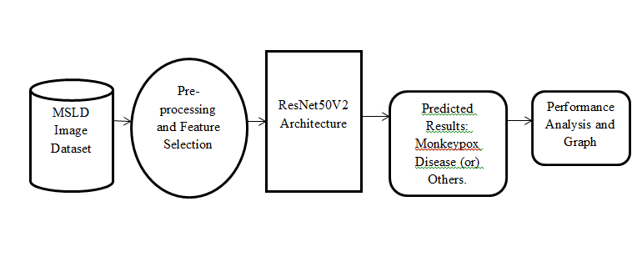

Figure : Architecture of Proposed System

ADVANTAGES OF PROPOSED SYSTEM

The following are the advantages of proposed system:
- Early Detection and Rapid Response: One of the primary advantages of the proposed system is its ability to provide early detection of monkeypox cases. By leveraging Deep Learning and the ResNet50V2 model, the system can swiftly analyze skin lesion images and identify potential cases of monkeypox in real-time. Early detection enables healthcare professionals to respond promptly, implementing appropriate containment measures and reducing the disease's spread within communities.
- Accessibility and Wide Reach: Unlike traditional diagnostic methods that rely on specialized laboratory facilities, the proposed system is accessible through a user-friendly web application. This accessibility enables individuals from various geographical locations, including remote or resource-constrained areas, to utilize the system without the need for expensive laboratory equipment or highly trained personnel. As a result, the system's reach is expanded, enhancing the detection of monkeypox across diverse populations.
- Cost-Effectiveness: The adoption of the proposed system offers cost-effectiveness in comparison to conventional diagnostic methods. The elimination of expensive laboratory tests, reagents, and specialized equipment reduces the financial burden on healthcare facilities and facilitates the scalability of monkeypox detection efforts, even during large-scale outbreaks.
- Accurate and Consistent Diagnosis: Deep Learning models, such as ResNet50V2, excel at image recognition tasks and demonstrate a high level of accuracy in classifying skin lesion images as either 'Monkeypox' or 'Others.' The system's consistency in providing accurate results contributes to reducing misdiagnoses and ensures reliable diagnostic outcomes across different users and regions.

MODULES:

- Dataset
- Importing the necessary libraries
- Retrieving the images
- Splitting the dataset
- Building the model
- Apply the model and plot the graphs for accuracy and loss
- Accuracy on test set
- Saving the Trained Model

HARDWARE REQUIREMENTS

- System : Pentium i3 Processor.
- Hard Disk : 500 GB.
- Monitor : 15’’ LED
- Input Devices : Keyboard, Mouse
- Ram : 6 GB

SOFTWARE REQUIREMENTS

- Operating system : Windows 10 Pro.
- Coding Language : Python 3.10.9
- Web Framework : Flask

Internal Guide Major Project Coordinator

